EVALUATION CRITERIA | Type | Weight | Project Title
SAMIS Linkage Count
Addresses an MRGESCP Science Strategy | count | 1.0
Addresses an Independent Science Panel Recommendation | count | 1.0
Reduces an uncertainty identified from a Conceptual Ecological Model | count | 1.0
Data or findings will inform other projects | count | 1.0
Reduces an uncertainty identified in a completed project
Linkage Total
S.M.A.R.T. Score¹
Specific – Hypothesis or objective is clearly articulated | score | 0.3
Measureable – Targets and methods are robust and appropriate | score | 0.3
Attainable – Activity is feasible with achievable outcomes | score | 0.2
Relevant – Activity is within the purview of the MRGESCP | score | 0.1
Time-bound – Timeline is defined and reasonable | score | 0.1
S.M.A.R.T. Total
Resilience Planning Score¹
Activity informs planning for future scenarios (e.g., changes in climatological conditions, anthropogenic impacts, species status, etc.) | score | 0.4
Activity represents an innovation or improvement over status quo | score | 0.3
Inference can be applied beyond the scope of the original activity | score | 0.3
Resilience Total
¹1 - Strongly Disagree, 2 - Disagree, 3 - Neutral, 4 - Agree, 5 - Strongly Agree
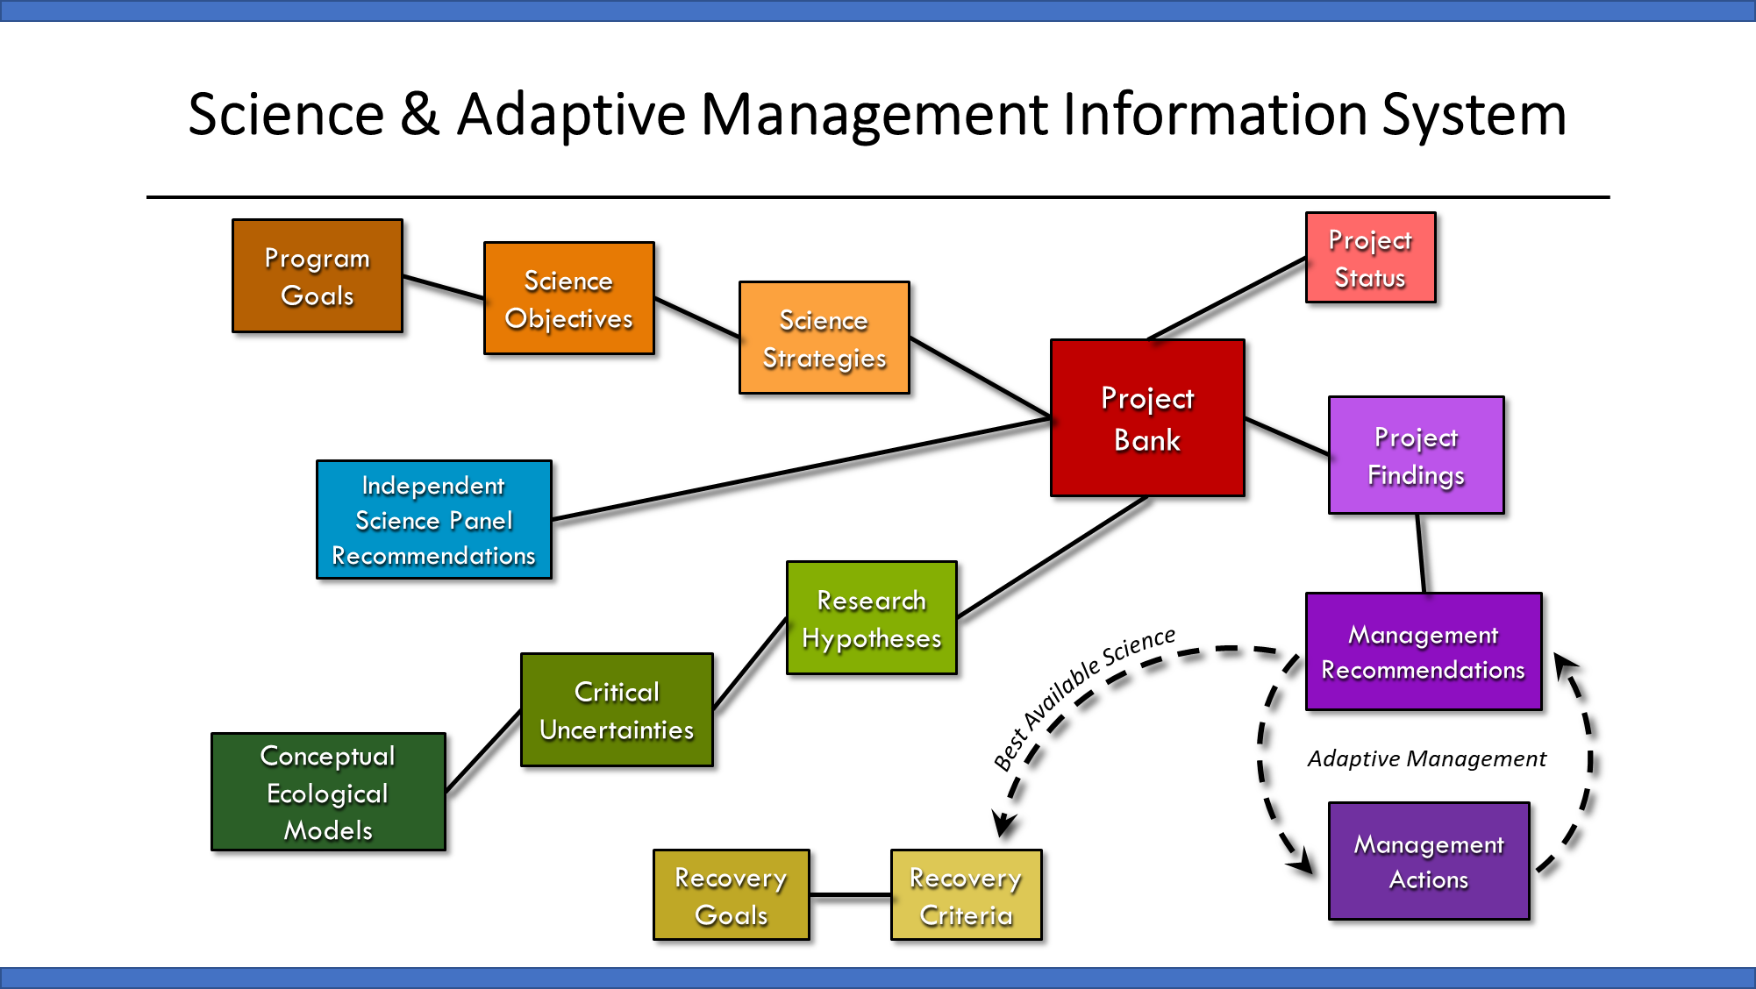
- The Linkage Count is a tally of all the direct linkages a project has to important features in the SAMIS (see schematic above). The Linkage Score appraises the intrinsic value of the project to the Collaborative Program.
- The S.M.A.R.T. Score is a weighted score assigned by the SAMC that appraises the comprehensibility of a project’s scope of work. Weights in the table above can be set to 1.0 if all criteria are considered equally important.
- The Resilience Planning Score incorporates a forward-looking element into the evaluation criteria and appraises the value of the project to adaptive management. Projects that address changing climatological conditions, increasing anthropogenic impacts, or changes in species status would score points here. Projects that present significant innovations or generate broadly-applicable inferences would also score highly.

