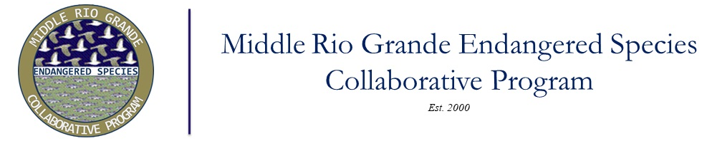

Proposed Options for the future of the MRGESCP Read-Ahead for the 9-23-25 Executive Committee Meeting:

EC Future Options (original list from Facilitated EC Meeting, December 2024):
      - An EC of Water Management agencies within the Collaborative Program, advised by and supported by non-water management members.
      - A Water Management subgroup, within the Collaborative Program. Parallel to SAM Committee for example.
      - A Water Management Team outside of, and separate from, the Collaborative Program with scaled back CP scope.

Suggested Revisions to EC Future Options:
      - An EC of Water Management agencies within the Collaborative Program, advised by and supported by non-water management members providing scientific and technical recommendations in response to queries from the EC.
        - Q: if this option is chosen, is it to be BO-Centric?
      - A Water Management subgroup, within the Collaborative Program and/or BO-Centric Subgroup. The Water Management/BO-Centric subgroup would be another committee that would operate under the EC (such as the FPC).
        - Q: What direction would the EC provide to such a group?
        - Q: Do we have the capacity to support it?
      - An information sharing and coordination Program, guided by the EC (i.e. Signatories and other parties bring items to Program for coordination/feedback)

