Middle Rio Grande Endangered Species Collaborative Program
Internal and External Peer Review

Introduction
The Collaborative Program’s committees and groups are tasked with producing administrative and scientific work products in support of the Collaborative Program’s operations and implementation of the Science & Adaptive Management Plan. Administrative work products include documents such as By-Laws, a Long-Term Plan, and annual reports. Scientific work products include documents such as technical reports, literature reviews, study designs, and scopes of work, as well as adaptive management tools like conceptual ecological models and population models.

The Collaborative Program incorporates peer review into its internal processes to ensure robust and defensible work products. Additionally, the Collaborative Program has procedures for seeking external reviews if an issue merits independent appraisal due to its importance for decision support or level of contention.

The Collaborative Program delineates four categories of peer review:
- Internal Administrative Review
- Internal Scientific Review
- External Expert Review
- Independent Science Panel

Each category can involve one or more type of review: content, statistical, editorial, contextual, legal and programmatic (Table 1). Specifying the type of review that is being requested expedites the process by focusing an individual reviewer’s time and attention on appropriate aspects of the work product.

Table 1. Definitions of Review Types
REVIEW TYPE | DEFINITION
Content Review | Checking a document for completeness and accuracy of the content and cited literature
Statistical Review | Evaluating research and sampling designs and application of statistical methods
Editorial Review | Evaluating a document’s style, grammar, formatting, and references
Contextual Review | Evaluating a document’s relevance to the Collaborative Program’s mission, goals and/or management needs
Legal Review | Evaluating a document’s relationship to policy, statute, and case law
Programmatic Review | Evaluating the entirety of a program or initiative with respect to efficacy and relevance of results or targets

Internal Peer Review
Internal peer review is carried out within the Collaborative Program and administered by the Program Support Team at the direction of the Executive Committee (EC) or Science and Adaptive Management Committee (SAMC). The two internal categories of peer review utilized by the Collaborative Program, internal administrative review and internal scientific review, are summarized below (Table 2).

Table 2. Categories of Internal Peer Review Used by the Collaborative Program
 | BEING REVIEWED | CONSIDERATIONS
Internal Administrative Review | - Governance documents (e.g., By-Laws, Science & Adaptive Management Plan)  - MRGESCP-authored documents (e.g., Annual Report) | - Reviewed by all signatories  - Contributes to MRGESCP operations  - One set of comments from each signatory
Internal Scientific Review | - S&T Ad Hoc Group work products (e.g., technical reports, scopes of work)  - Science and AM tools (e.g., conceptual ecological models)  - External requests for review by the MRGESCP (e.g., study designs, monitoring plans) | - Reviewers with relevant expertise  - Performed or delegated by the SAMC  - May include external reviewers if supplementary expertise is needed  - Individual comment forms

Internal Administrative Review
Internal administrative documents that are authored by the Collaborative Program and/or are essential to Collaborative Program governance and operations are reviewed by all the signatories. Examples include the By-Laws, annual reports, the Science & Adaptive Management Plan, and the Long-Term Plan. An internal administrative review is conducted by the Program Support Team (PST), which compiles individual signatory reviews, incorporates changes and, as appropriate, catalogs edits and responses to comments when finalizing a document for EC approval.

Internal Scientific Review
Internal technical reviews are delegated by the Science and Adaptive Management Committee (SAMC) to one or more reviewers with appropriate qualifications and relevant subject matter expertise. This type of review is applied to Science & Technical (S&T) Ad Hoc Group deliverables, technical reports, study designs, models, and other work products relating to the science program. A request for a review by the Collaborative Program by an organization (either a signatory or external to the MRGESCP) may also be considered for internal scientific review.

Typically, reviewers are selected from Collaborative Program participants, but if a need for supplementary expertise is identified, the SAMC can request external individuals to participate in the review. Internal scientific reviews are collected via individual comment forms, on which reviewers can provide scientific justifications for their comments, when needed. All comments received are compiled and delivered to the originating authors and the SAMC. Changes and responses to comments are cataloged for future reference. If a scientific uncertainty can be justified from an unreconciled comment about the strength or validity of findings, it will be incorporated into the Science and Adaptive Management Information System (SAMIS).

External Peer Review
External peer review is performed by individuals from outside the Collaborative Program. The review is administered by a third-party contractor to avoid bias. The two external categories of peer review utilized by the Collaborative Program, external expert review and independent science panel, are summarized in Table 3.

Table 3. Categories of External Peer Review used by the Collaborative Program
 | BEING REVIEWED | CONSIDERATIONS
External Expert Review | - A singular work product (e.g., Science & Adaptive Management Plan, population models)  - The topic has a medium-to-high level of contention  - The work product may be administrative or scientific | - SAMC recommends & EC approves  - Expert reviewers  - Administered remotely  - Does not require interaction between reviewers and MRGESCP experts  - Individual comment forms or a report
Independent Science Panel | - Broad, complex and consequential topics  - The topic has a high level of contention | - Programmatic review  - SAMC recommends & EC approves  - Expert reviewers  - In person, multi-day  - Requires interactions between review panel and MRGESCP experts  - Panel report

External Expert Review
In the event that a work product has a large amount of influence on research direction, quality of management recommendations, or Collaborative Program operations, and involves a high degree of scientific uncertainty, the SAMC may recommend it for an external expert review. Individuals from outside the Collaborative Program are nominated to perform the review, and support is provided remotely via conference calls or web conference. Reviewer comments may be documented with individual comment forms or a consensus report. The work product under review should be complete enough to provide all necessary information to the reviewers without further need to interface with the MRGESCP.

The administration of an external expert review would be contracted by a signatory organization to a third-party, adding time and cost burdens. Therefore, the SAMC must justify a recommendation to the EC to hold an External Expert Review. If approved, the EC directs the Fiscal Planning Committee (FPC) to coordinate with the signatories to decide which signatory will fund the external expert review. The SAMC may include in its recommendation the format of the deliverable required for the review, such as a consensus panel report or individual comment forms.

The third-party contractor administering the external expert review may be the PST.

Independent Science Panel
The Collaborative Program has sponsored several Independent Science Panels. These tend to be costly and time-intensive for both the reviewers and Collaborative Program participants. Independent Science Panels are multi-day, in-person meetings with technical presentations from Collaborative Program scientists to the panel members, who have spent time prior to the meeting reviewing relevant scientific literature and other background materials. Given the resource-intensive nature of Independent Science Panels, these are reserved for broad, complex issues that are consequential to scientific understanding and trajectory of research, and have influence on management decisions.

In the event that the SAMC recommends the use of an Independent Science Panel, appropriate justifications regarding scope, impact and uncertainty of the review topic are provided to the EC. An Independent Science Panel requires EC approval and a signatory contracting a third-party to administer of the panel. The third-party administering the Independent Science Panel may be the PST.

Following the formal meeting and panelist deliberations, the Independent Science Panel drafts a panel report, which is provided to the Collaborative Program for review. Comments received are compiled by the contractor and addressed, as appropriate, by the Panel. The findings and recommendations from the Independent Science Panel are presented to the Collaborative Program in a public seminar, and archived in the SAMIS.

Table 4. Comparison of the different categories of review used by the Collaborative Program.
 | INTERNAL ADMINISTRATIVE REVIEW | INTERNAL SCIENTIFIC REVIEW | EXTERNAL EXPERT REVIEW | INDEPENDENT SCIENCE PANEL
Cost | $ | $ | $$-$$$ | $$$$
Time commitment | Low | Low | Medium | High
Clear charge to reviewers | X | X | X | X
Expert reviewers |  | X | X | X
External reviewers |  | If needed | X | X
SAMC recommends & EC approves |  |  | X | X
Paid reviewers |  |  | X | X
Contracting needs |  |  | X | X
Panel report |  |  | If needed | X
In-person |  |  |  | X
Interaction between reviewers and work product authors/ technical experts |  |  |  | X

The detailed process for carrying out an internal or external scientific peer review is found in Section II.

Scientific Peer Review

Decision-Support Process for Scientific Peer Review
The process of peer review involves different types and levels of assessment, based on the item under review. Considerations for selection of the appropriate type and level of peer review include the scope of the topic, the level of contention involved, the expertise that is available, and availability of time and funding.

Internal scientific review is built into the Science and Adaptive Management Plan and is routinely undertaken for all technical work products produced by the Collaborative Program. External peer review requires contracting a third-party to administer the review, a greater time commitment on the part of the reviewers, greater costs, and, in the case of an independent science panel, a significant time investment on the part of Collaborative Program subject matter experts.

The SAMC determines the appropriate level of peer review for a particular work product or topic, as well as the type(s) of review (Table 1) that are needed: content, statistical, editorial, contextual, or programmatic. The flow chart shown in Figure 1 provides guidance for selecting the appropriate level and type of review.

Figure 1. Decision flow chart for the appropriate category of peer review
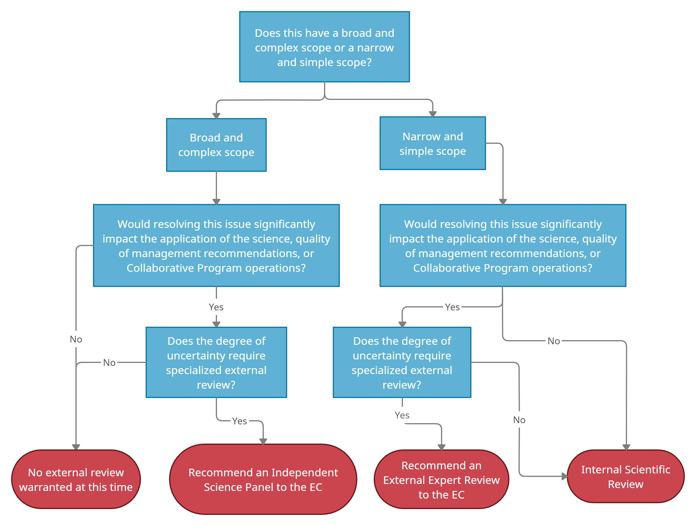

Internal Scientific Review Process
Each of the Collaborative Program’s technical work products receives some level of internal scientific review. Work products may include, but are not limited to: technical reports and papers; conceptual, statistical and mechanistic models; and literature reviews and syntheses. Most work products are produced internally by S&T Ad Hoc Groups, although the Collaborative Program may get an external request to provide a scientific review of a manuscript, report, study design, monitoring plan, or other item. All internal scientific reviews are under the purview of the SAMC and supported by the PST.

The following steps comprise the Collaborative Program’s internal scientific review process:

- When the SAMC forms an S&T Ad Hoc Group, it indicates if there is a need for a review of the deliverable(s) in the group’s charge, including a list of proposed reviewers and the type of review. Not all S&T Ad Hoc Group deliverables will require a review, but if the topic is influential for scientific understanding due to level of uncertainty or incompatible findings, then the additional review is warranted.

The S&T Ad Hoc Group lead may also submit a request for review of the group’s deliverable to the SAMC.

- After the S&T Ad Hoc Group delivers a draft product, the PST validates all cited references prior to internal scientific review and/or SAMC review. This entails checking that all references have been cited correctly and are accessible. If a reference cannot be validated, the PST will communicate with the S&T Ad Hoc Group lead to either correct or remove the citation.

- If the SAMC indicates the need for a deliverable review in the S&T Ad Hoc Group’s charge, potential reviewers are contacted. Once the reviewers are confirmed, they are given a clearly-stated charge (e.g. type(s) of review to perform, due date), the work product to be reviewed, and individual comment forms to record their comments and provide additional references. If an editorial review is requested by the SAMC, editorial changes can be tracked directly in the document, for convenience.

- The PST compiles the individual comments received and provides them to the S&T Ad Hoc Group lead, who then incorporates changes and addresses each of the reviewers’ comments. If the work product under review is a request from an external organization, the compiled comments are conveyed to the originating authors, and no further steps are required.

- The revised work product is delivered to the SAMC along with the archive of comments received with responses and changes made. The SAMC reviews the work product and determines whether the findings, conclusions, and recommendations are well-supported or require further investigation or analysis.

- Supported findings, conclusions, and recommendations from the work product are entered into the SAMIS. Topics identified as needing further investigation or analysis during the internal scientific review or subsequent SAMC review are noted in the SAMIS as scientific uncertainties, where applicable.

- As appropriate, the SAMC may include recommendations for future scientific work in the next update to Long-Term Plan, to be approved by the EC. Recommendations for best management practices may also be generated during review of these work products and inform the larger context of the science program.

External Review Process
When a scientific topic or question is broad and complex, with a high degree of scientific uncertainty and influence on management recommendations, the SAMC may consider resolving it through an external review. Given that external reviews (i.e. External Expert Reviews and Independent Science Panels) require more resources than internal reviews, the SAMC must justify the need when recommending an external review to the EC. If the EC agrees and approves such a review, it then directs the FPC to coordinate resources. The signatory that contracts the external review coordinates with the SAMC regarding the charge for the reviewers to accommodate any contracting requirements.

The following steps compose the Collaborative Program’s external scientific review process:

- The SAMC considers a work product or topic for external review based on its scope, complexity, uncertainty and influence on policy, and/or in the event of a deficiency of required expertise within the Collaborative Program.

- The SAMC completes the proposal to the EC to recommend holding an external review, including: the category of review (External Expert Review or Independent Science Panel), a draft charge for the review panel, the required expertise and desired qualifications for the reviewers, and the specified deliverable and timeline.

- The EC reviews the SAMC proposal and decides on the external review at its next meeting. If approved, the EC then sends the proposal to the FPC to coordinate resources.

- The contracting signatory tasks a third-party contractor with the administration of the external review, including the following:
  - Identifying and vetting of potential reviewers, in coordination with the SAMC
  - Subcontracting of reviewers, including collecting conflict of interest disclosures and agreements pursuant to the code of conduct (Section III)
  - Providing the appropriate literature and supplemental information to the review panel
  - Facilitating the review:
    - For an External Expert Review, the review is conducted remotely. The contractor compiles and organizes individual comments, and hosts conference calls or web conference meetings, as needed, with the External Expert Review panel.
    - For an Independent Science Panel, the third-party contractor plans a multi-day meeting, including:
      - Securing meeting space, and handling meeting logistics
      - Identifying appropriate Collaborative Program technical experts to present to the review panel, and coordinating the content, scope and order of the presentations
      - Developing a meeting agenda
      - Running the multi-day Independent Science Panel meeting
      - Note-taking at the meeting and summarizing discussions
      - Any necessary follow up

- The reviewers for either type of review documents their findings.
  - External Expert Review: The review panel may submit individual reviewer comment forms, which the third-party contractor compiles and presents with a cover memo to the SAMC for evaluation and recommendations to the EC (skip to step 9). An External Expert Review may, at the request of the contracting signatory, instead provide a consensus panel report (continue to step 6).
  - Independent Science Panel: The panelists must produce a panel report, which includes findings, recommendations, areas of disagreement amongst the panelists, and all appropriate references (continue to step 6).

- The SAMC conducts an initial content review of the draft panel report, focusing on responsiveness to the original charge and noting areas where additional clarity may be needed.

- Collaborative Program experts are given the opportunity to review and provide comments on the draft panel report. The third-party contractor is responsible for distributing the draft report and comment forms, collating and compiling received comments, and providing the compiled Collaborative Program comments to the panelists.

- In coordination with the panelists, the third-party contractor documents the received comments and how they were addressed in revisions to the panel report.

- The External Expert Reviewers or the Independent Science Panel panelists finalize their respective work product and the third-party contractor delivers the final version to the SAMC.

- The third-party contractor and/or reviewers/panelists deliver a presentation of findings and recommendations to the Collaborative Program. The presentations are open to an audience of all interested Collaborative Program participants.

- The SAMC synthesizes the External Expert Review or Independent Science Panel findings, submits a cover memo that recommends next steps in support of the science and adaptive management program with the finalized deliverable to the EC.

- The PST records all findings and recommendations in the SAMIS. Important topics that demonstrate incompatible or inconsistent findings, with appropriate evidence, are classified as potential critical uncertainties in the SAMIS.

Scientific Peer Review Code of Conduct
Peer review is integral to the scientific process and improves the quality of the scientific work products being produced by the Collaborative Program. To ensure the integrity of the peer review process, reviewers and those administering reviews must adhere to the following code of conduct.

Reviewers
By consenting to participate in a peer review of a work product, reviewers agree to:
- Disclose any conflicts of interest prior to their agreement to participate in the review.
- Review the work product according to the charge assigned.
- Provide scientific justification for their comments.
- Provide reviews in a professional and constructive manner.
- Have their comments made available to the work product authors, the SAMC, the PST, and to have them documented in SAMIS.

Contracting Signatory
External Expert Reviews and Independent Science Panels are contracted to a third-party to administer. In order to ensure an unbiased and independent review, the signatory that manages the contract agrees to:
- Incorporate the charge developed by the SAMC and approved by the EC into the performance work statement, to the extent possible given contracting requirements.
- Allow the third-party contractor to perform its work of administering the external review without attempting to influence the process, the selection of reviewers, or the findings and recommendations from the reviewers.
- Direct the third-party contractor to follow the peer review process outlined above in Section II, including coordinating with the SAMC on the panel charge, identification and vetting of potential reviewers, and incorporating a SAMC content review of any panel report in the work plan.
- Provide any comments on the panel report as part of the Collaborative Program’s opportunity to review (step 7 above).
- Deliver the reviewer comments or final panel report to the SAMC without further revisions.

Third-Party Contractor
A third-party is contracted by a signatory to administer an External Expert Review or an Independent Science Panel. This entity is vital to ensuring the independence of the review process. To that end, a third-party contractor must:
- Protect the integrity of the external peer review process.
- Administer the review in a transparent manner consistent with the steps outlined in Section II.
- Ensure the reviewers have equal access to all relevant information and data in order to carry out the review.
- Remain neutral in its treatment of all signatories and technical experts.
- Support the reviewers in their work without influencing the outcome of the review.
- For an Independent Science Panel, ensure the panelists hear from presenters representing the full range of scientific opinion.
- Ensure communication of the reviewers’ comments, findings, and recommendations to the SAMC.
- For a panel report, ensure presentation of the report’s findings to the Collaborative Program.

